Noah Buchen
CS362-Winter 2019
12 Jan 2019
Assignment 1

Card | Use
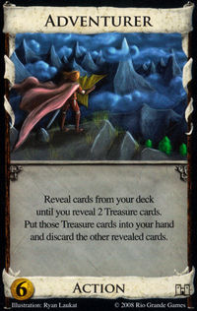 | An action card, the adventurer will allow the player to search their deck for the first two treasure they find discard the other cards one at a time. Cost = 4
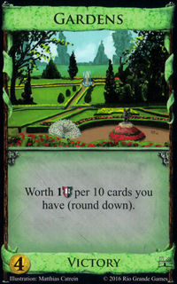 | A point card, the garden awards the player 1 victory point for every 10 cards in their deck. ex. 44 cards = 4VP. Cost = 4
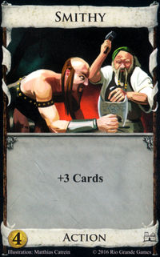 | An action card, the smithy allows a player to draw 3 additional cards from their deck to use during their turn. Cost = 4
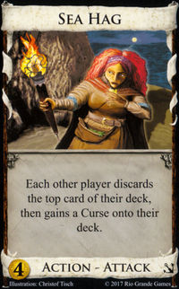 | An attacking action card, the sea hag requires your opponent to discard the top card from their deck and then add a curse card (-1 VP) to their deck. Cost = 4
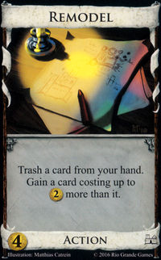 | An action card, remodel allows the player to remove a card from their hand and deck (a.k.a. trash a card) and then gain a card up to 2 more then the cost of that card. Cost = 4

